

PROJECTOR CALCULATOR

PJ-CALC

Version 1.0.0.0

USER’S MANUAL

**Contents**

1. Introductions 3

2. Main user interface 4

Reset, User guide , Export, Language and Maximum windows 4

3. Projector & Lens 5

3.1 Projectors information 5

3.2 Lens information 5

3.3 Select the projector from the project types list 6

3.4 Search the projector by model name 6

4. Input installation conditions 7

4.1 Basic Setting 7

4.2 Room Size 7

4.3 Screen Size 7

4.4 Screen Position 8

4.5 Projector Position 9

4.6 Brightness Estimation 10

5. View 11

5.1 Change View 11

5.2 Side view 11

5.3 Front view 12

5.4 Top view 12

5.5 3D view 13

5.6 Projected image position 14

6. Others and Export simulation results 14

# Introductions

"Projector Distance Calculator" is a PC-based application software that is used to calculating the throw distance between screen and the Vivitek projector. Mainly to help you choose a suitable projector for your room. It calculates the relationship between the size and distance of the projected image, and recommends the proper placement of the projector.

*Please note: The calculation are for estimation purposes only, It can’t absolutely guarantee the actual performance. The projection distance is the distance from the center of the lens tip to the screen. Before installing any parts of the projector, please go to the official website to detail study the product specifications or contact the local system installer for support.

*When using the Vivitek Projection Calculator software, please use the latest version.

# Main user interface

(1)

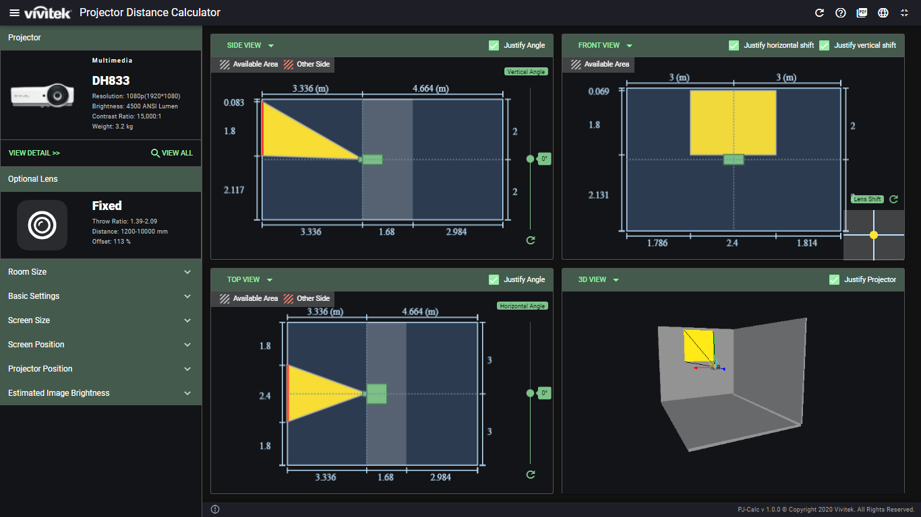

(2)

(3)

(4)

|

(9)

(10)

Menus and Functions in the Main user interface are shown below.

|  |  |
| --- | --- |
| Tab | Description |
|  | Reset, User guide , Export, Language and Maximum windows |
| 1. Projector | Select and show the projector for installation |
| 1. Lens | Show and select the available lens for calculation |
| 1. Basic Setting | Select the units and installation type for all calculation |
| 1. Room Size | Setting the room dimension for calculating |
| 1. Screen Size | Setting the screen dimension for calculating |
| 1. Screen Position | Setting the screen position for calculating |
| 1. Projector Position | Setting the projector position for calculating |
| 1. Brightness Estimation | Brightness estimation guide |
| 1. View | This provides 2D and 3D perspective views of the projector installation area |

# Projector & Lens

## Projectors information

The name, photo and dimensions of the selected projector will show up. Discontinued models will show up with an alert.

The basic specification of the projector include photo, resolution, brightness, contrast, throw ratio and weight (For interchangeable lens projectors, the weight does not include the lens.)

For more detail product information, click on the model name and the website link will take you to the webpage for the more projector information.

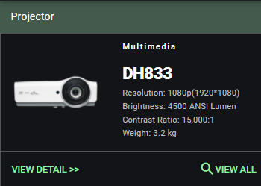

## Lens information

This shows the information for projector models with lens type (fixed or exchangeable lenses), lens throw ratio, throw distance and offset.

Select an optional lens interchangeable lens projectors only）, you can also select a different lens when calculating throw distance, image size, etc. Projectors with single fixed lenses will show up as fixed.

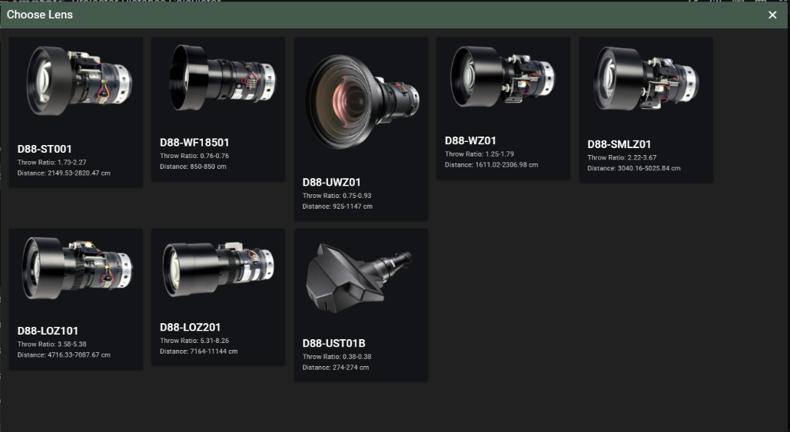

## Select the projector from the project types list

Click Select the projector from the projector types you would like to install.

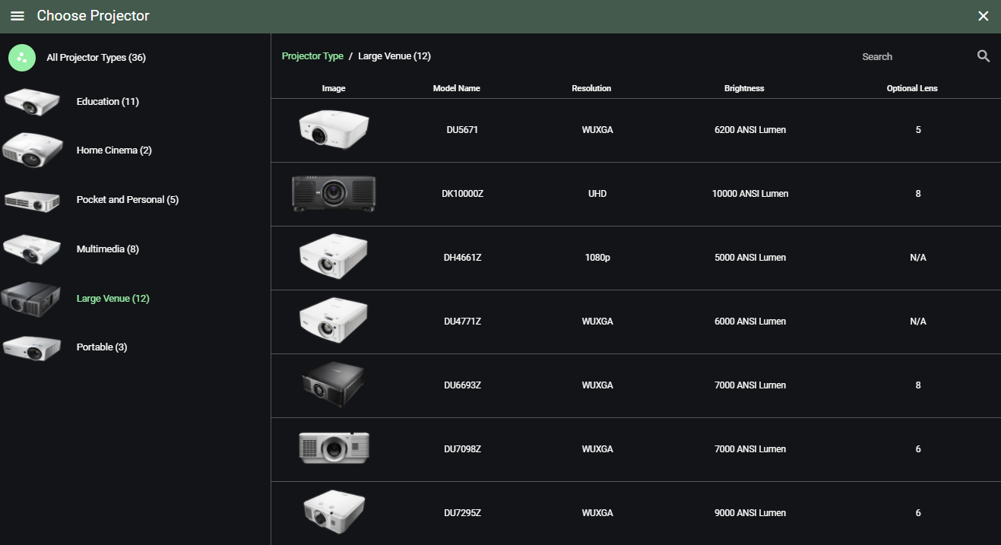

## Search the projector by model name

Please input the partial or complete model number to find a specific model or list of matching projector models. After you input a model name or parts number the automatically populates in the Model Name box and you can select from a list of models from the pull-down menu.

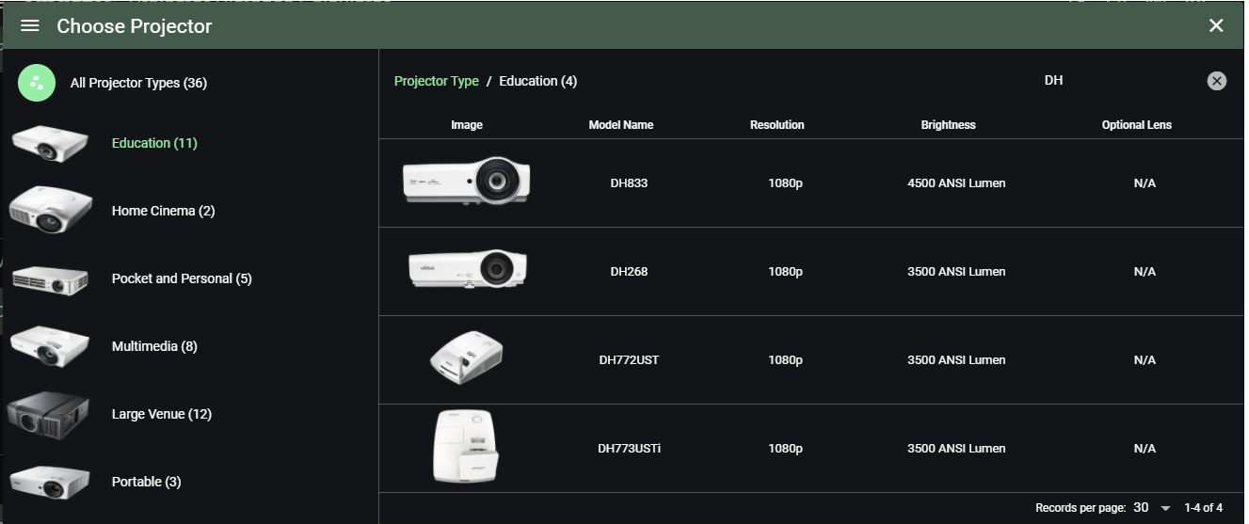

# Input installation conditions

## Basic Setting

* Units

Select the calculation unit including meters, centimeters, millimeters, inches and feet

* Installation

Projectors can be placed on a desktop or ceiling mounted.

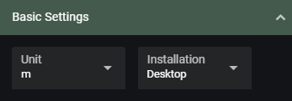

## Room Size

The projection distance and screen size will be limited by the size of the environment. Please enter the room dimension for calculating.

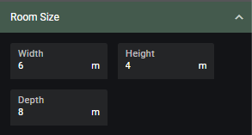

## Screen Size

Key in your desired screen size. The width, height and diagonal will depend on the aspect ratio you have chosen. These fields adjust automatically when entering a value in any of the boxes, so you don’t need to input all values.

If the key in screen size is bigger than the room size, the available value automatically to the maximum or minimum value according to the input value.

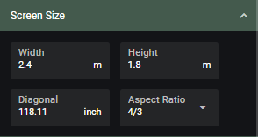

* Aspect Ratio

Select the image aspect ratio you would like to display. When the aspect ratio setting is changed from the initial value, the black band will appear on the left/right or top/bottom of the screen image.

|  |  |
| --- | --- |
|  | The default is 16:10 aspect ratio, When you change to “16:9”, The black will mask on the top/bottom of projection image. |
|  | The default is 16:10 aspect ratio, When you change to “4:3”, The black will mask on the left/right of projection image. |

* Lock function

The key in screen size will be locked

## Screen Position

* From left wall

Key in the width from left wall to left of screen.

* From floor

Key in the height from floor to bottom of screen.

* From front wall (Offset)

Key in the thickness if you use whiteboards and so on.

* Lock function

The screen position will be locked

## Projector Position

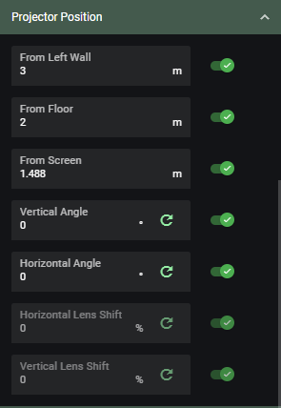

* From left wall

Key in the distance from left wall to the center of screen.

* From floor

Key in the height from floor to the center of screen.

* From screen to lens (Throw distance)

Key in the throw distance, the input value is limited according to the lock status of the screen size.

* Projector angle

Simulate diagonal projection in horizontal or vertical direction. You can enable the function in the vertical and horizontal directions at the same time. When this function is enabled, the slider and input box will appear in the side view or top view window.

* Lock function

The projector position will be locked

Please Notes :

- If the screen size is not locked, the screen size will automatically be adjusted to the largest size in the room size.

- Screen size is locked, If the input throw distance is within the range limits, the position of the projector in the “View” boxes will adjust accordingly.

## Brightness Estimation

This is the brightness of the image based on the distance of your projector to the screen, screen gain and zoom settings, When key in room brightness and screen gain, you can confirm whether the actual brightness, screen contrast, and the brightness of the selected projector are sufficient appropriate.

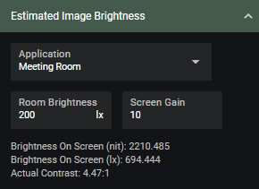

* Application

If you do not know the brightness of the installation environment, please select the application list from the drop-down menu. It will automatically bring into the regular brightness level of each application scenario. If the brightness of the installation environment has a specific brightness level, please select "Custom" and enter the brightness value.

* Room brightness

Key in the brightness value of the installation environment. If you use a measuring tool to measure the actual brightness, it is recommended that you measure the brightness of the wall surface on which the image is projected.

* Screen gain

Please key in the screen gain according to the screen specification, A normal white wall is designated 1 for screen gain. Screens with better reflective indexes will have a larger screen gain, giving the viewer a brighter perception of the projected image.

# View

You can visualize the position of the projector in the 2D and 3D perspective areas, and even change five views format.

## Change View

* Select the view layout : Two/Equal, Two/Horizontal, Two/Vertical, Single and Three/Above.
* Change the view type: You can change (swap) views.

## Side view

This provides a 2D perspective from the side of the room. The is the room viewed from the side. The projector position setting can be changed using a mouse.

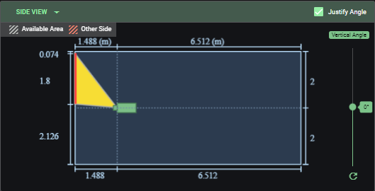

* If you want to change the position of the projector without changing the screen size, first lock the screen size.
* If the selected model uses an optional lens shift function, "Available Range" will be displayed. If you want to change the position of the projector within the available range area, first lock the screen size and screen position.
* When the vertical angle is set to "ON", the slide bar and input box will appear on the right side of the view box.
* The reset button returns the adjustments to their default settings by clearing all entered data and adjustments made to the illustration.

## Front view

This is the view when facing the wall where the image is projected.

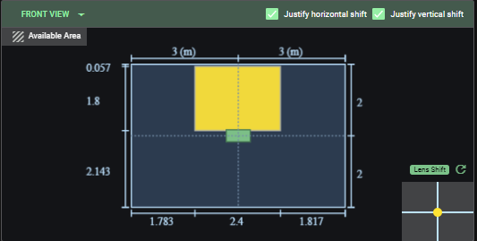

* If the selected projector supports the lens shift function, the "Available Range" will be displayed. If you want to change the position of the projector within the available range, use the lens shift slider (right: vertical lens shift, bottom: horizontal lens shift).
* If you want to move the projector position (and lens shift position) horizontally to the center, press the "Center" button.
* The reset button returns the adjustments to their default settings by clearing all entered data and adjustments made to the illustration.

## Top view

This is the room view from the top.

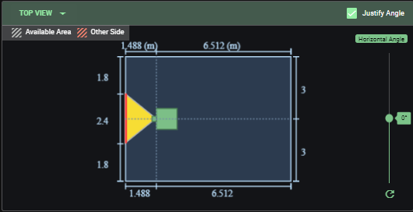

* The basic operation is the same as “Side view”.
* When the horizontal angle is turned “ON” , the slider bar and the input box will appear on the right side of top view area.
* The reset button returns the adjustments to their default settings by clearing all entered data and adjustments made to the illustration.

## 3D view

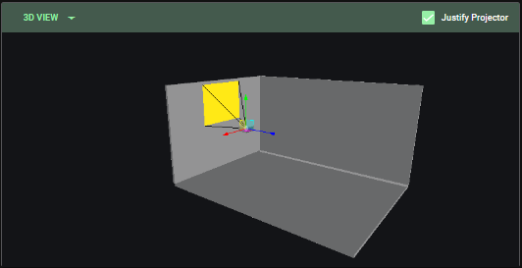

* This is the 3D room view. Operations are as follows:
* Zoom: Rotate the mouse wheel or drag the mouse while clicking the wheel.
* Rotation: Drag the mouse while left clicking.
* Pan: Drag the mouse while drag the mouse while right-clicking.
* Move the projector position by dragging the mouse while left clicking on surface around the projector.

Rear : Up-down or Left-right direction

Left/Right : Front-back direction

Top: Front-back or Left-right direction

## Projected image position

If any part of the projected image hits the side wall, ceiling or floor, the image beam will show a shaded pink – see example below.

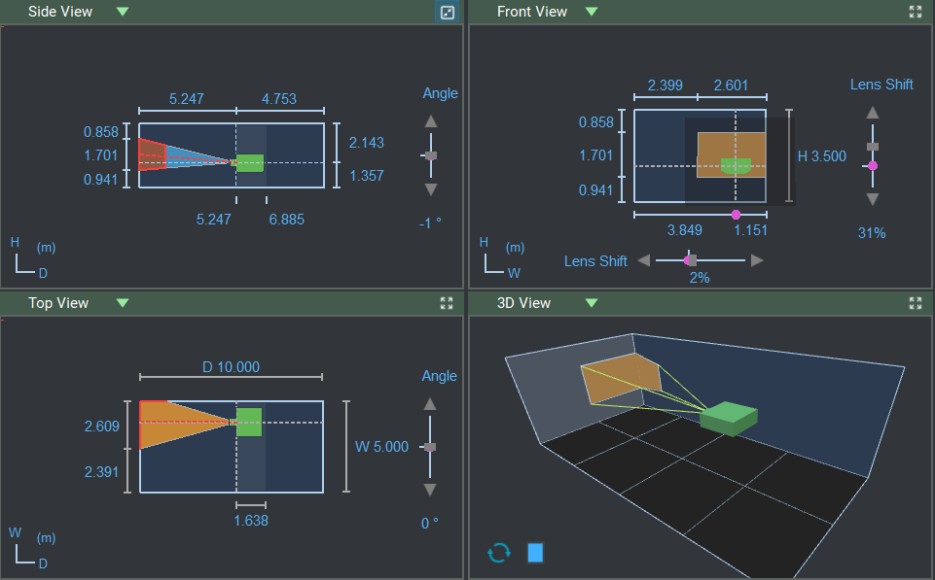

# Others and Export simulation results



|  |  |  |
| --- | --- | --- |
|  | Reset | The reset button reverts the projection distance calculator back to its default settings by clearing all data entered and adjustments made to the illustration. |
|  | User Guide | Open user’s manual |
|  | Save as PDF | You can save the data and illustrations after a session as a PDF file. |
|  | Language | Select the language list from the drop-down menu. |
|  | Reset | Maximum browser windows |